|  |  |
| --- | --- |
| **1** | **Create a WordPress plugin which contains the following functionality**      Plugin created to create custom post type Character. |
| **2** | **Create a post type “Character”**    Custom post type created with the help of plugin    For this used register_post_type function in wordpress and pass the array and assign it to init hook |
| 3 | Create a custom field: ID for the post type Character (without a plugin)        Saving custom field value with help update_post_meta using save_post_{custom_post_type} hook |
| 4 | **When a Character post is created or updated, update the post meta**  When the character post is created or update the post meta is updated with the help of update_post_meta() function and using save_post hook |
| 5a | **Once the post is updated, run an API call to this API:** [**https://thronesapi.com/api/v2/Characters/**](https://thronesapi.com/api/v2/Characters/)**<id> with the ID being the one the user entered in the post**    **wp_remote_post** and **wp_remote_retrieve_body** function is used to get json response from API and json_decode is used to decode json to php object |
| 5b | **Update the post’s title to be the `fullName` field of the character from the API**      **wp_update_post** is used to update custom post type character title with fullname |
| **5c** | **Update the post’s featured image to be the image from the API `imageUrl`**      First uploaded image in media library through code using file_put_content () and created the attachment.  Set_post_thumbnail function is used to insert featured image from url and for that we need attachment id so wp_insert_attachment    **Final Result 👍**    **Front End**    There is a background image above there is overlay and then title and button |

Css used

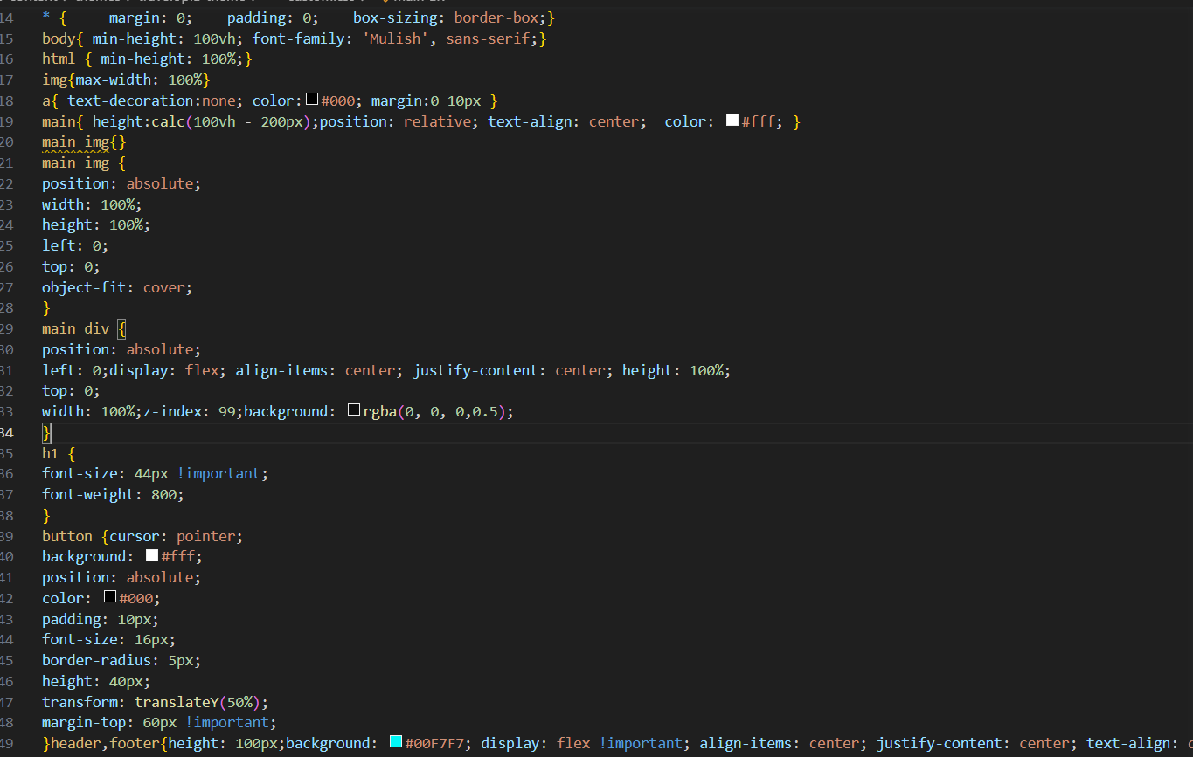

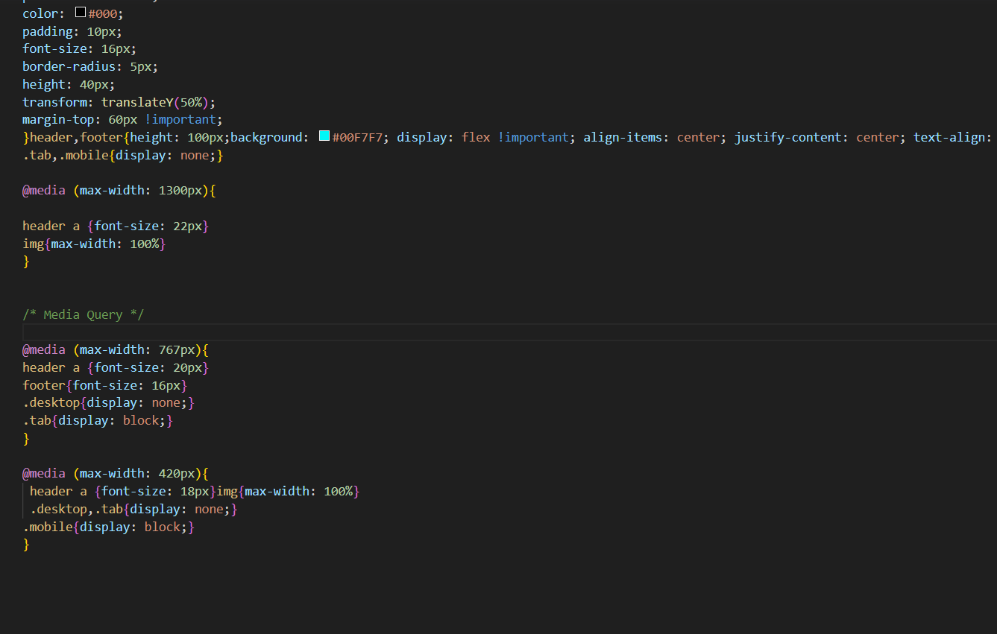

Media query used for responsive screen

Main div css is used for translucent overlay and button css is added for button

Button is added with name Click here

Added alert box through custom js with the help of enqueue script

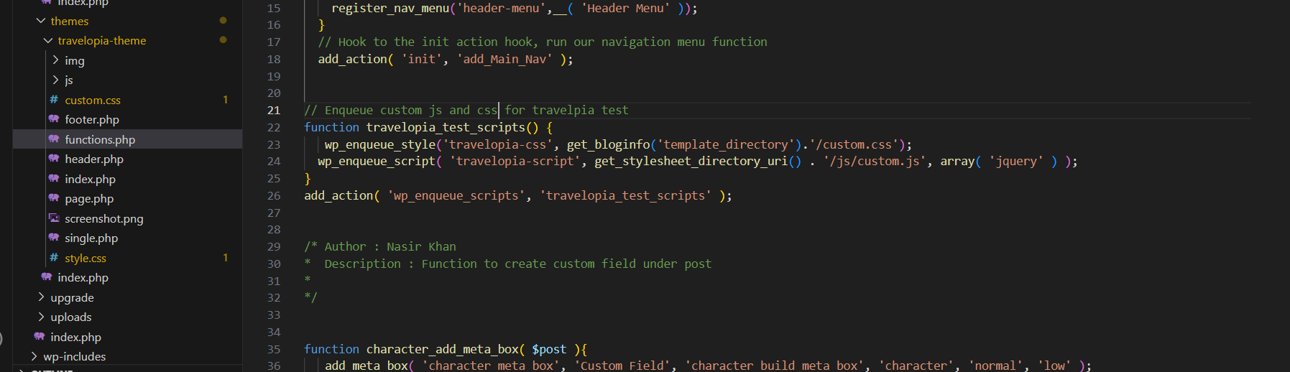

Custom css added through enqueue script

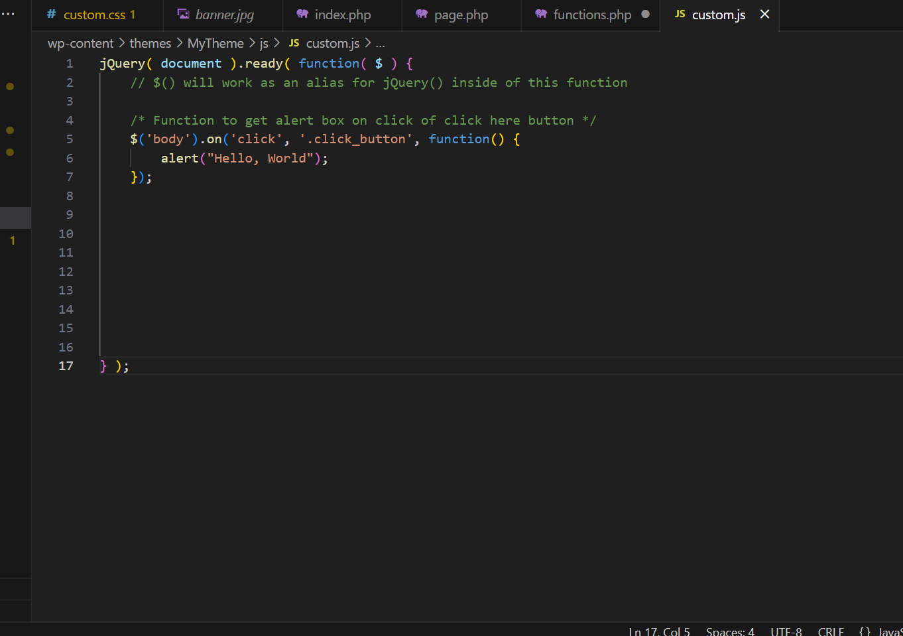

**For setting up**

<http://localhost/frontendtest>

Frontend - folder name used

Technology : MySql, Wordpress, Php